Customer Desiring Appeal Creator Application

Done by Sulaiman Alsharji

Introduction

Now and so on we are among the era of development, innovation, disruption and digital – driven direction where there are many attractions between transformation swift and human being desires and needs. When it comes to toss the innovation creativity plus quality of human beings the digital transformation lead is a spectacular effective solution to toss human beings life’s higher towards better life, greater productivity, ace of technology, less time, effort fee and lower cost. The effectful disruption could be navigated via simplicity, creativity and effectiveness of genuine ideation.

The innovative ideation

An app of software that consult and design whatever customer desire accord to interesting information of customer requests based on, product type, attitude and behavior of customer service, solving customer appeal problem, timing of desired solution plus appeal, high degree of personalization due to service, generator of self – lead for users to innovator and inventor once product ready, unstoppable customer support, genuine listener based on AI, ML, IoT and cloud computing technology, top level of accuracy, an ace of assist and consultancy based on appeal data, peak level of interconnection and with such product or service of companies, clients plus stakeholder based customer requirements. As well an advanced development based on is tied with Blockchain to perform the optimum range of transaction, transparency, security and trust.

C:\Users\USER\AppData\Local\Temp\ksohtml6152\wps1.pngC:\Users\USER\AppData\Local\Temp\ksohtml6152\wps2.png

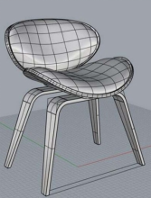

C:\Users\USER\AppData\Local\Temp\ksohtml6152\wps4.pngC:\Users\USER\AppData\Local\Temp\ksohtml6152\wps5.png

C:\Users\USER\AppData\Local\Temp\ksohtml6152\wps11.png

Once the design appear after user (customer) setting the consultancy will appear to suggest the best level of design could customer add to get the optimum of desired design, product and the list of companies with specification plus prices, as well the entire detailed form of design product which CDAC app deal with for design appealed via customer taste. The below process is continue of what we explained.

CDAC process

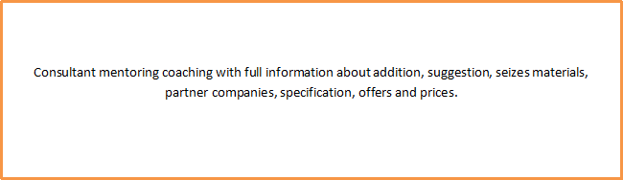

The app is chain of design, model, consult, coach, suggestion, offers and price. The app will be available in both of Apple store and Play store.

**Our Ideation matching with harmony Oman vision 2040**

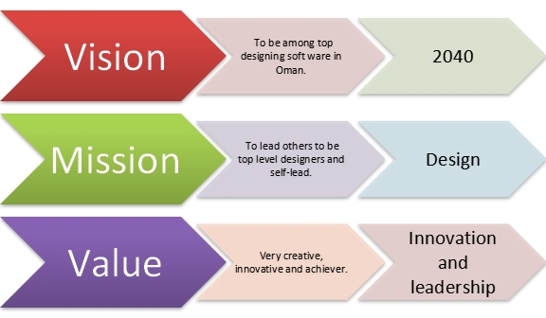

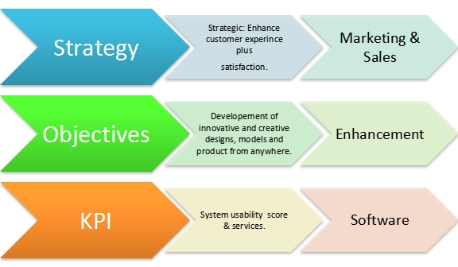

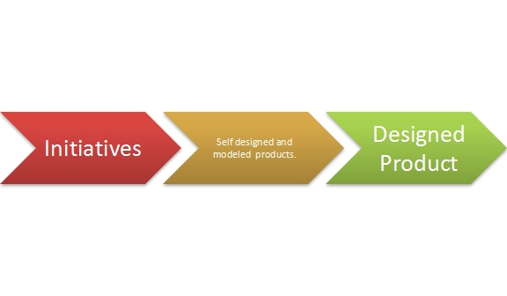

**Point of View (POV) Statement**

|  |  |  |
| --- | --- | --- |
| User | Needs | Insight |
| Customers who looking for self-lead design freely, full digital consultant coaching, addition, suggestion and execution. | To create designs, models and products based on human beings appeal  To up skill, school and train users to be professional designers.  Easy, simple, adjustable and creator.  Highly transparent, trusty, accurate and errorless.  Could be functioned over any language with international standards. | Big reduce in expenditure, easy to design, less time, efforts, self-lead and desired models.  Very skillful user’s outcome, self-lead and self-learn.  Could be adjusted, seted and controlled easily with low cost, low time, in many moods, less efforts, from anywhere plus anyone.  Culture of transparency, trust, accuracy, less errors, creativity, innovation, disruption and achievement.  Very diverse, various and wide of usage plus options. |

**How Might We (HMW) Statement**

How Might We (HMW) we design a swift Digital Customer Desiring Appeal Creator Application that boom amazing level of extremely designs based on users, consultancy and suggestions that promote desired product chiefly, for customers who looking to execute their taste product within fast time, high accuracy, easy engage, very cheap and big data.

Digital Customer Desiring Appeal Creator Application is very various plus suitable accords to functions, needs, users and advantages. High degree of trust and transparency that provided by digital system extremely clear, precious and easy to recognize to gain best results. High degree of design, coach, suggestion and offers based on customer design results. Developed technology which runs a design platform plus an app with high specification.

Certainty of functioning due safe, cheap, swift, errorless, simple maintenance and clean.

Include comprehensive bonds with ace companies that provide finishing once desired customer product ready for made. Could be functioned via laptop over windows or mac + tabs, pads among play store or apple store.

|  |
| --- |
| Customer journey map  I.Watching our advertisement, read or hear about us plus our product via company website plus app, social media platform, blogs and, radio, calls about app functions, uses and digital manual.  II.Watching info graphic or YouTube video tutorials about functioning, designing, modeling and questioning about specific product.  III.Full user manual which contain detailed explanation about Customer Desiring Appeal Creator (CDAC) app to be mastered.  IV.An entire, measurement, voice command, designing, modeling, coaching, suggestion, pricing plus offering.  Digital transaction based on tied advanced CDAC app with Blockchain.  VI. Comprehensive detailed report about the desired designed modeled product based, specification, options and finishing through transacted payment.  VII.Valuable customer experience expression and impression via CDAC app Chatbot plus feedback. |

**Empathy user map**

Users are daily consumers and mostly their ages between 18 – 80 years old whether males or females around the world.

|  |  |
| --- | --- |
| *Says*  I require something reliable and transparent.  The designing tools are spectacular.  The coaching, suggestion and mediation between user (customer) and companies is awesome.  I want to receive full data about my transaction, product specification, features and price.  I want to receive my delivery highly trusted, guaranteed and as I ordered. | *Thinks*  Am I getting optimum price?  Am I getting special offer?  Am I having discount?  Would it be useful and beneficial?  Will it reach on time?  What is a super about the product?  Anything missed?  I hope things will go and be will?  Am I reaching the peak of my desired designed product? |
| *Does*  Prepare budget.  Make comparison about products.  Make comparison about prices.  Perform contacts. | ***Feels***  Superb.  Confused.  Diffcult.  Happy.  Stress.  Passion.  Satisfaction.  Untrustable  Reward able. |

**Press Release**

|  |  |
| --- | --- |
| **Heading** | Maximizing innovation, creativity, modeling , enhancing top level of consultancy, coaching, suggestion and broker between customer designed product and related company to his or her specific design. |
| **Sub - Heading** | We will give the best experiences via outstanding customer service, attractive competitive prices, high security, great transparency and big trust by reducing time, efforts and cost. |
| **Summary** | Our ideated product provides great experience for customer due the functions and features which it promote useful, innovative and creative tools that make designing, modeling and finishing easier, smarter, joyful and very beneficial. |

|  |  |
| --- | --- |
| **Problem** | Not having broker which links their designed product with related company to it. As well people having their own design from A-Z based to their taste plus desire as well, executing it to be full ready product. |

|  |  |
| --- | --- |
| Solution | Our ideated Software app plus platform will provide effective and beneficial solutions for any (user) customer:  Easy and smart way to master designing, modeling plus finishing step by step from A to Z.  High degree of trust and transparency and integrity.  Providing several of options, suggestions, instruction, coach, execution and offers.  Certainty of functioning due safe, cheap, swift, errorless, simple maintenance and update accord to be tied to Blockchain (Ethereum) which is an advance in all aspects.  Could be hired from anywhere via Windows, mac, play store, Apple store.    Accord to All sectors Customer Desiring Appeal Creator (CDAC) which enhances comprehensive, innovative, creative, effective, solutions for having live design as user exactly for any customer need. Also the software is an advance way to generate creative innovators and inventors based on process of CDAC = design + modeling + product + execution. As well secure, trust, transparent and accurate, also highly developed with partnering with Blockchain (Ethereum) and can be engaged from any place and could be shifted to anywhere through mobile, laptop and PC. |

|  |  |
| --- | --- |
| **Quote of us.** | ‘Our era is an embracement of top innovative, creative designs. When designs become models plus product that’s the booming of advance modern life’.  -Sulaiman Alsharji- |
| **How to get started?** | Visit our future website  www.cdac.om with details to manual user, full coach and tutorials. As well design, model and execution ideated product. |
| **Customer Quote.** | ‘The app is a combination of self-lead, richness of ideation and innovation, creativity plus execution with high possibility for anyone’.  -Loyal customer- |
| **Call to action.** | General Call to Actions  Find us for location.  Read more for more information.  Like as feedback.  Watch now for demonstration demo.  Download for specifications, user manual and tutorial.  Donate for charitable purposes about Sultanate of Oman plus the world.  Add to cart for adding the product of customer’s online shopping cart.  Design as you like your product to be.  Get full suggestions, coach, finishing and mediation with related company to user (customer) designed product.  Subscribe to link customer with certain product.  Purchasing for design + model + a product which designed. |

**Prototype of design**

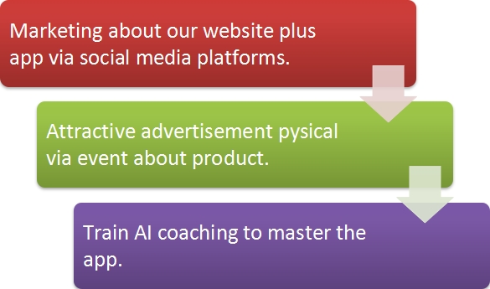

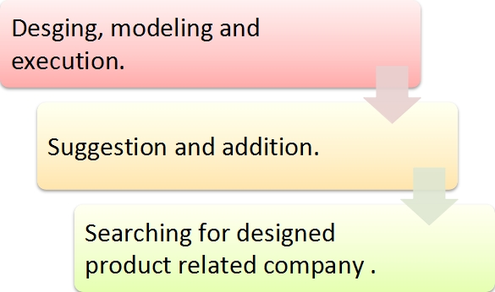

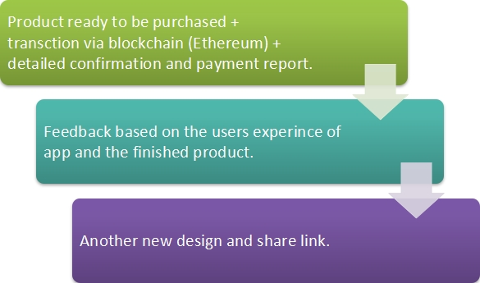

**Prototype Testing**

|  |  |  |  |  |
| --- | --- | --- | --- | --- |
| **Interview Questions** | **User 01** | **User 02** | **User 03** | **User 04** |
| What did you  like about the  app? | Very smart | Easy to use and control | High quality coaching and suggestion | Extremely develop and liked me to the proper related company to my design |
| What did you  dislike about  the product? | The richness of instruction | Very detailed | Many process | The price of dealing company |
| How did you  feel about  the product? | Saver of time, money and effortless | Joyful plus valuable  experience | Very handy, beneficial and reward | Very safe, secure, trusty and transparent |
| Any features  you want to  remove? | Chatbot services | Nothing | Plenty of details | Total  fees |
| Any features you  want to add? | More updates | Bigger community | Top level customer service | Website design |
| Would you  recommend this  app? | Yes | yes | yes | yes |
| Rating you  Would you assign to  product from 1  to 5? | 5 | 3 | 4 | 5 |

**Product price**

The net prices of Customer Desiring Appeal Creator (CDAC) App free trial then 6.7 OMR/month.

The final fresh designed product depends on product specification as well the shipping.

**Competition and context**

To reach high level of productivity, transparency and trust we have to engage:

1- Feasibility:

Disruption to boom the market.

Agile business good be very effectful to optimize the productivity.

Comprehensive range of relationship and mediation of companies.

2- Desirability:

To implement Methodologies that the customer is first via agile methodology.

**Business model canvas**

|  |  |  |  |  |  |  |  |  |  |  |
| --- | --- | --- | --- | --- | --- | --- | --- | --- | --- | --- |
|  |  | *Designed for:* | | | | *Designed by:* | | *Date:* | | *Version:* |
| **Business Model Canvas** | | CDAC | | |  | S.Alsharji |  | 2/24/23 |  | 1 |
|  |  |  | | | |  | |  | | |
| **Key Partners** | **Key Activities**  Design coaching | | **Value Propositions** | | | **Customer Relationships** | | **Customer Segments** | | |
| Cloud provider (Azure).    Payment provider  Google pay  PayPal. | Providing designing, modeling and finishing.  Mediation between user (customer) and desired designed product. | | Transparency.  Trust.  Super-fast.  Lower expenses.  Smart contracts. | | | Customer service.  Coaching + suggestion.  Customer support 24/7.  High security.  Feedback.  Transparency + trust. | | Designing and modeling of product and services.  Product making.  Product + shipping fees. | | |
| **Key Resources** | | **Channels** | |
| Requirement due to customer requests such as:  Verification.  Documentation + report.  Receiving conformation.  Entire designed product. | | Company Website.  Company software app.  Social media platforms. | |
| **Cost Structure** | | | | **Revenue Streams** | | | | | | |
| Develop, design and update of Customer Desiring Appeal Creator (CDAC) App + Employee salary packages.  The smart contracts via Blockchain (Ethereum), NFT , Initial company offerings, Mediation with companies which cover customer design. | | | | Crowd funding.  Transaction revenue.  Product + shipping revenue.  Recurring revenue. | | | | | | |

**Advantages of Business Model**

No chances of error and dispute as every transaction in digital is observed and recorded by plenty of servers.

Fraud percentage is zero, accord to the level of security which is very high via digitalization.

The transaction easily could be achieved from any spot around the world based on requirement of ID and personal documents.

Top level of transparency pre, during or after the buying or selling via website use manual, demo and customer service.

Top level of tutorial virtual coaching to master the app.

Very strong levels of mediation with appropriate company which cover the executed design to be full product as customer want.

**SOWT table**

|  |  |  |  |  |
| --- | --- | --- | --- | --- |
| # | Strengths | Weaknesses | Opportunities | Threats |
| 1 | Leading by example | Sometimes the connection could be lower. | Always I am looking to lead by example because it is very influential way to affect the team to achieve more and better. | Sometimes based on work pressure I must make very proper time management, high level of wireless communication to achieve the best with the shortest time as much as I can. |
| 2 | Transformational leadership. | Something new and innovative which will change the routine. | Establishes powerful relationships, Serves as an ideal influence,  Provide enthusiasm and motivation via being support of learning and stimulates creativity plus innovation. | Very linked trust through the employee which accord to team members of recognize each other clearly. |
| 3 | Embracing change | Must be understood among entire organization based on high level of stress for changing the work process and management. | Minimize the negative manner about change and be more acceptable for current and future based on modernizations. | Not proper understanding about change which requires full understanding via proper training and implementation. |
| 4 | Disruptive Innovation | New technology over the new stages. | Increase market plus revenue, reduce cost, optimize productivity, lower time and expand network. | Highly innovative and creative which could be solved via talented, innovative and creative employee and an advance technology. |
| 5 | Growth mindset | Maximizing the entire team growth mindset. | Increasing learning, development, positivity and problem solving and financial development and booming. | When some employees not attract to the development as much as they can, it could be solved through spreading growth mindset among organization, proper motivation and awareness. |
| 6 | Organizational culture. | Requiring high level of arrangement and regulation. | Maximizing productivity, smart contracts and innovation. | Lack of execution. |
| 7 | Personal leadership | Less about making mistakes and developing good understand among team. | Increase cooperation and collaboration. | No good values, which must be with high morales, integrity, transparency and trust. |
| 8 | Seamless Communication. | Requiring very developed high tech. | Maximizing relations among team, customers and stakeholders. | Improper listening which could be replaced with clear communication and listening. |
| 9 | Strong vision. | Requiring a lot of efforts and high tech. | Maximizing the future goals. | Unsuitable strategy which could be solved via excellent strategic planning and execution. |
| 10 | Commitment | High level of daily concentration through team. | Increasing self-confidence and commitment. | Being careless which could be solved by high determination, commitment and team work. |

**Cash flow forecast**

|  |  |  |  |  |  |  |  |  |  |  |  |  |  |
| --- | --- | --- | --- | --- | --- | --- | --- | --- | --- | --- | --- | --- | --- |
| CASH FLOW FORECAST (Omani rial) | January | February | March | April | May | June | July | August | September | October | November | December | Total |
| CASH FLOW INTO THE BUSINESS |  |  |  |  |  |  |  |  |  |  |  |  |  |
| Family Loan | 450000 | 0 | 0 | 0 | 0 | 0 | 0 | 0 | 0 | 0 | 0 | 0 | 450000 |
| SALES PRODUCT and Services | 3500 | 5001 | 6800 | 7010 | 7500 | 7770 | 8006 | 8050 | 8300 | 8380 | 8450 | 8900 | 46900 |
| TOTAL CASH FLOW IN | **45500** | **5001** | **6800** | **7010** | **7500** | **7770** | **8006** | **8050** | **8300** | **8380** | **8450** | **8900** | **91900** |
| CASH FLOW OUT OF THE BUSINESS |  |  |  |  |  |  |  |  |  |  |  |  |  |
| Capital Expenditure items (Capex) |  |  |  |  |  |  |  |  |  |  |  |  |  |
| Premises | 0 | 0 | 0 | 0 | 0 | 0 | 0 | 0 | 0 | 0 | 0 | 0 | 0 |
| Vehicles | 3500 | 0 | 0 | 0 | 0 | 0 | 0 | 0 | 0 | 0 | 0 | 0 | 3500 |
| Office Equipment | 700 | 150 | 20 | 10 | 5 | 12 | 0 | 18 | 7 | 9 | 0 | 6 | 937 |
| Design software | 350 | 0 | 0 | 0 | 0 | 50 | 0 | 0 | 0 | 0 | 0 | 0 | 400 |
| Capex TOTAL | **4550** | **150** | **20** | **10** | **5** | **62** | **0** | **18** | **7** | **9** | **0** | **6** | **4837** |
| Operating Expenditure items (Opex) |  |  |  |  |  |  |  |  |  |  |  |  |  |
| Salaries (gross amount totals) | 4000 | 4000 | 4000 | 4000 | 4000 | 4000 | 4000 | 4000 | 4000 | 4000 | 4000 | 4000 | 48000 |
| Life Cover Scheme | 200 | 225 | 235 | 245 | 260 | 275 | 280 | 285 | 290 | 295 | 300 | 300 | 3190 |
| Rent | 180 | 180 | 180 | 180 | 180 | 180 | 180 | 180 | 180 | 180 | 180 | 180 | 2160 |
| Local Taxes | 9 | 9 | 9 | 9 | 9 | 9 | 9 | 9 | 9 | 9 | 9 | 9 | 108 |
| Combined Business Insurance | 11.7125 | 11.7125 | 11.7125 | 11.7125 | 11.7125 | 11.7125 | 11.7125 | 11.7125 | 11.7125 | 11.7125 | 11.7125 | 11.7125 | 140.55 |
| Utilities | 155 | 155 | 155 | 155 | 155 | 155 | 155 | 155 | 155 | 155 | 155 | 155 | 1860 |
| IT Charges; Phones, WiFi, and Website | 105 | 105 | 105 | 105 | 105 | 105 | 105 | 105 | 105 | 105 | 105 | 105 | 1260 |
| Smart contract | 650 | 0.4 | 0.4 | 0.4 | 0.4 | 0.4 | 0.4 | 0.4 | 0.4 | 0.4 | 0.4 | 0.4 | 654.4 |
| Accounting, payroll & audit charges | 540 | 30 | 35 | 30 | 32 | 30 | 30 | 30 | 1680 | 30 | 37 | 29 | 2533 |
| Business travel | 0 | 0 | 0 | 400 | 0 | 0 | 0 | 0 | 470 | 0 | 0 | 0 | 870 |
| Bank charges | 11.5 | 11.5 | 11.5 | 11.5 | 11.5 | 11.5 | 11.5 | 11.5 | 11.5 | 11.5 | 11.5 | 11.5 | 138 |
| Co-founders loan repayment | 0 | 0 | 0 | 0 | 0 | 0 | 0 | 0 | 0 | 1950 | 2130 | 2175 | 6255 |
| Digital Marketing | 300 | 290 | 275 | 250 | 235 | 225 | 220 | 205 | 195 | 180 | 170 | 165 | 2710 |
| Raw materials | 0 | 0 | 0 | 0 | 0 | 0 | 0 | 0 | 0 | 0 | 0 | 0 | 0 |
| Opex TOTAL | **6162.2** | **5017.6** | **5017.6** | **5397.6** | **4999.6** | **5002.6** | **5002.6** | **4992.6** | **7107.6** | **6927.6** | **7109.6** | **7141.6** | **69878.8** |
| TOTAL CASH FLOW OUT | **10712.2** | **5017.6** | **5037.6** | **5407.6** | **5004.6** | **5064.6** | **5002.6** | **5010.6** | **7114.6** | **6936.6** | **7109.6** | **7147.6** | **74715.8** |
| MONTHLY NET CASH FLOW | **34787.8** | **-16.6** | **1782.4** | **1602.4** | **2495.4** | **2705.4** | **3003.4** | **3039.4** | **1185.4** | **1443.4** | **1340.4** | **1752.4** |  |
| MONTHLY BANK BALANCE | **34787.8** | **34771.2** | **36553.6** | **38156** | **40651.4** | **43356.8** | **46360.2** | **49399.6** | **50585** | **52028.4** | **53368.8** | **55121.2** |  |

**Conclusion**

Customer Desiring Appeal Creator (CDAC) app is an option of design, self-lead, support, better life, innovation, creativity and transformation. The approach of self-lead while designing maximizes the leadership, creativity, transformation among market and business. CDAC will coverage for our new era requirement new design will promote new product which will boom the money, work opportunities which will enhance better economy and higher quality life.

Reference

* Lewrick, M. (2018). The Design Thinking Playbook: Mindful Digital Transformation of Teams, Products, Service: Willey.
* Rogers, D. (2016). The Digital Transformation Playbook: Rethink Your Business for the Digital Age.
* Perkin ,N. and Abraham,B. (2017). Building the Agile Business through Digital Transformation: How to Lead Digital Transformation in Your.
* Stickdorn, M. (January 2, 2018.) This is service design doing : applying service design thinking in the real world : a practitioner’s handbook.
* [online]. Available from: <https://99designs.com/blog/web-digital/how-to-design-an-app/>
* [online]. Available from: <https://www.designrush.com/best-designs/apps>
* Prior, P. (2017) Your First CFO The Accounting cure For Small Business : KBO Sales, Inc.
* Cohan, P (2019) Scaling Your Startup: Mastering the Four Stages from Idea to $10 Billion : Apress.
* Theil, P. and Masters, B. (2014). Zero to One: Notes on Startups, or How to Build the Future: Ebury Publishing.
* Templar, R. (2012) The Rules of Money: How to Make It and How to Hold on to It : FT Press.
* Greber, M. (2008) Awakening the Entrepreneur Within: How Ordinary People Can Create Extraordinary Companies: Harper business.
* Reeves, M. & Haanaes, K. & Sinha, J. (2015) Your Strategy Needs A Strategy : How to choose and Execute the right approach, Harvad Business Review Press.
* Meadows, M . (2017) The Ultimate Focus Strategy : How To Set The Right Goals, Develops Power Foucs, Stick To The Process, AND Acheve Success : Meadows Publishing.